Ghana Football Association (GFA) Management Information System
Comprehensive System Security Report: CIA Triad, Two-Factor Authentication, & Salt/Pepper Architecture
Academic & Candidate Identification | Details
Candidate / Author Name | Daniel Boateng (Oti-Boateng)
Student Identification (ID) | 26130005
Institution & Department | Pentecost University / Department of Information Technology
Course / Module | Information Security & Secure System Development
GitHub Account & Repository | https://github.com/OTI-BOATENG/gfa-system
Cloud Live Deployment URL | https://gfa-system-seven.vercel.app
Core Cryptographic Stack | Argon2id (m=65536, t=4, p=1), 16-Byte CSPRNG Salt, Server Pepper, Time-based 2FA OTP, RBAC, Automated Disaster Recovery Backups

1. Executive Summary & System Overview
The Ghana Football Association (GFA) Management Information System is an enterprise-grade secure web portal engineered in PHP and MySQL to manage association operations, national team squads, executive committees, and official membership rosters. Built from the ground up under rigorous defense-in-depth principles, the architecture addresses modern cyber threat vectors, credential breaches, and unauthorized privilege escalation.
To satisfy the core information assurance mandates, the system integrates a multi-layered cryptographic pipeline featuring per-user 16-byte cryptographically secure salts, an isolated application pepper secret, and the memory-hard Argon2id hashing algorithm. Furthermore, user authentication is guarded by a mandatory Two-Step / Two-Factor Authentication (2FA) one-time passcode workflow, strict Role-Based Access Control (RBAC) isolating Administrator, President, and Captain privileges, and automated daily disaster recovery backups via mysqldump.
★ OFFICIAL SUBMISSION LINKS
Live Production & Source Deliverables:
• Source Code Repository: https://github.com/OTI-BOATENG/gfa-system
• Live Cloud Application: https://gfa-system-seven.vercel.app
• Default Demo Users: admin, president, captain (and nanaquesi0206@gmail.com) with password AdminPass123!

2. Information Assurance: The CIA Triad Architecture
The classical CIA Triad (Confidentiality, Integrity, and Availability) forms the foundational benchmark for evaluating system security posture. The GFA system systematically addresses each facet through tailored technical countermeasures:
2.1 Confidentiality
Confidentiality ensures that sensitive identity and operational records remain strictly inaccessible to unauthorized entities, eavesdroppers, or hostile actors. In the GFA System, confidentiality is enforced through four primary mechanisms:
1. High-Entropy Credential Protection (Salt & Pepper with Argon2id): Passwords are never stored in plaintext. They undergo concatenation with a global server-side pepper and a 16-byte per-user dynamic salt before being transformed by the memory-hard Argon2id algorithm. Even if attackers obtain a raw database dump, hashes cannot be reversed without the isolated server pepper.
2. Mandatory Two-Factor Authentication (2FA): A compromised or intercepted password is insufficient to breach the system. A secondary, single-use 6-digit cryptographic token with a strict 5-minute lifespan must be verified before any session token is granted.
3. Session Isolation & Principle of Least Privilege: Sessions store minimal identifiers (user ID, username, role name) rather than passwords or personal data. Role-based guards prevent unauthorized access to operational dashboards.
4. Cryptographic Session Signing: Session identifiers and payload metadata are secured using HMAC-SHA256 signatures, ensuring session tokens cannot be forged, modified, or hijacked across distributed serverless environments.
2.2 Integrity
Integrity guarantees that data and state remain authentic, consistent, and unaltered by unauthorized parties or technical malfunctions. The GFA system implements robust integrity controls:
1. Parameterized Prepared Statements (SQLi Prevention): Every database interaction utilizes PHP Data Objects (PDO) prepared statements with parameterized inputs. SQL commands and user data are strictly bifurcated, neutralizing SQL Injection (SQLi) attacks across all registration, login, and dashboard routes.
2. Relational Foreign Key Integrity & Cascading Constraints: Relational schemas enforce strict foreign key constraints (e.g. FOREIGN KEY (role_id) REFERENCES roles(id) and ON DELETE CASCADE on 2FA records), preventing orphaned records, inconsistent states, or referential corruption.
3. Role-Based Access Control (RBAC) Enforcement: Mutation endpoints (adding/deleting players, appointing executives) verify role capabilities server-side on every request, ensuring captains or guests cannot spoof administrative modification commands.
2.3 Availability
Availability ensures authorized personnel have uninterrupted, prompt access to vital association records and operational tooling. The architecture secures availability through:
1. Automated Disaster Recovery Hot Backups: The system incorporates an automated backup engine (scripts/backup.php) that generates full mysqldump database snapshots with ISO-standard timestamps (e.g., gfa_backup_YYYYMMDD_HHMMSS.sql).
2. Database Backup Audit Logging: Every created snapshot is recorded with timestamp metadata in the backups database table for auditing, tracking, and compliance.
3. Resilient Multi-Driver Database Architecture: The database layer in src/db.php features an automated fallback to an embedded SQLite database in /tmp when MySQL is unavailable or deployed on stateless cloud hosts like Vercel, preventing single-point-of-failure downtimes.
Pillar | Threat Vector Mitigated | Technical Implementation in GFA System
Confidentiality | Credential theft, rainbow table attacks, offline database breach cracking | Per-user 16-byte dynamic salts, global server pepper, Argon2id hashing, and mandatory 2FA OTP verification.
Integrity | SQL injection, parameter tampering, unauthorized record manipulation | PDO parameterized queries, strict role-based capability validation, foreign keys with ON DELETE CASCADE.
Availability | Database corruption, server failures, accidental data loss, cloud outages | Automated mysqldump hot backups, audit logging in backups table, and zero-downtime serverless SQLite fallback.

3. Two-Step / Two-Factor Authentication (2FA) Architecture
Two-Factor Authentication is an essential defensive countermeasure that mitigates credential stuffing, phishing, and password reuse vulnerabilities. In the GFA System, authentication is segmented into two sequential gates:
3.1 Step 1: Primary Credential Validation
The user enters their username (or registered email) and plaintext password on public/index.php. The server retrieves the user record, extracts their unique salt, and verifies the candidate string against the stored Argon2id hash using verifyStoredPassword(). If validation fails, the attempt is terminated with a secured redirect.
3.2 Step 2: One-Time Passcode (OTP) Generation & Dispatch
Upon successful primary authentication, the system enters the secondary verification phase:
1. Token Generation: A cryptographically secure 6-digit numeric OTP is produced using random_int(0, 999999) and padded to ensure consistent 6-character length (e.g., '049281').
2. Cryptographic Storage: To prevent token leaks in case of an in-flight database dump, the OTP itself is never stored in plaintext. It is hashed using bcrypt (password_hash($code, PASSWORD_DEFAULT)) and inserted into the two_factor_codes table.
3. Strict Time-To-Live (TTL): Each code is stamped with an expiration timestamp set to exactly 5 minutes (TWO_FACTOR_EXPIRY_MINUTES = 5). Any verification attempt made after expiration is rejected with '2FA code expired'.
4. Academic Demo Badge: For evaluation and grading purposes, the generated OTP is conveniently displayed on the screen inside the secure 'Demo code' badge on auth/login.php.
3.3 Step 3: Verification & Session Issuance
When the user submits the code to auth/verify_2fa.php, the server executes strict validation:
• It queries the latest active OTP for that specific user ID.
• It verifies that the current timestamp is within the 5-minute validity window.
• It executes password_verify($submitted_code, $stored_code_hash).
• Once authenticated, the code is invalidated, the user session $_SESSION['user'] is established, an HMAC-signed authentication cookie is issued, and the user is redirected to their authorized dashboard.
★ 2FA WORKFLOW PIPELINE
Two-Factor Authentication Flow Summary:
User Input (Username + Password) ➔ Argon2id Verification ➔ Generate 6-Digit OTP ➔ Hash via Bcrypt ➔ Store with 5-Minute TTL ➔ User Submits Code ➔ Bcrypt Hash Verification ➔ Invalidate OTP ➔ Issue Role Session

4. Cryptographic Architecture: Salt and Pepper Implementation
Password protection in the GFA System is engineered against offline brute-force cracking, precomputed rainbow table attacks, and catastrophic database leaks. This is accomplished by combining per-user dynamic salts with an isolated application pepper.
4.1 Salt vs. Pepper Theoretical Comparison
Attribute | Per-User Dynamic Salt | Application-Wide Pepper Secret
Storage Location | Stored directly alongside user records in the MySQL users.salt database column. | Stored strictly outside the database in server environment variables or src/config.php.
Scope | Unique to every registered user account (16 random bytes). | Universal application secret shared across all credential candidate evaluations.
Primary Security Objective | Thwarts rainbow table attacks. Ensures two identical passwords produce completely different hash outputs. | Thwarts database breach exfiltration. If attackers dump the database, they cannot crack hashes without the isolated pepper.
Entropy Source | Cryptographically secure pseudo-random bytes generated via random_bytes(16). | High-entropy server secret string (e.g., 'GFA-DEMO-2026-Pepper').
Visibility to Attackers | Exposed if the database table is exfiltrated. | Remains hidden even if full SQL database dumps are publicly leaked.

4.2 Candidate Construction & The Argon2id Algorithm
Before applying the hashing function, the system constructs a combined candidate string using a deterministic pipeline:
Candidate String = Application_Pepper || Plaintext_Password || Per_User_Salt
This candidate string is processed by the state-of-the-art Argon2id algorithm, configured with memory-hard parameters:
• Memory Cost (m): 65,536 KiB (64 Megabytes of RAM per hash evaluation)
• Time Cost (t): 4 iterations across memory blocks
• Parallelism (p): 1 thread
Argon2id was selected because it combines Argon2d's resistance to GPU/ASIC hardware brute-forcing with Argon2i's resistance to cache-timing side-channel attacks, providing the highest level of cryptographic assurance recommended by OWASP and NIST.
4.3 Pepper Key Rotation & Resilient Fallback Handling
In enterprise deployments, security standards require periodic rotation of cryptographic keys. Changing an application pepper normally breaks all existing user passwords. To prevent this, the GFA System introduces an intelligent key fallback mechanism in src/config.php:
When verifyStoredPassword() executes, it first tests the candidate against the active primary pepper. If verification does not match, it sequentially tests against a whitelist of configured fallback peppers (PASSWORD_PEPPER_FALLBACKS). This enables seamless key rotation without invalidating user accounts or forcing administrative password resets.
4.4 Live Database Cryptographic Evidence
User ID & Name | Assigned Role | Per-User Salt (16-Byte Hex) | Argon2id Hash Preview
1 - admin | Administrator | 4ea22e14e1ba48f22edcbf4bd05b0cd6 | $argon2id$v=19$m=65536,t=4,p=1$dXBKLzdQbzk4...
2 - president | President | ffa94466c9c53b89b6543b9ecacf2fd7 | $argon2id$v=19$m=65536,t=4,p=1$SzE5SFB6LkM0...
3 - captain | Captain | f954f61622315c299a3cd78acd049491 | $argon2id$v=19$m=65536,t=4,p=1$U2VyTldPeEFU...
4 - OTI-BOATENG | Administrator | 9b81e285a8efb489d8cd2f694a112871 | $argon2id$v=19$m=65536,t=4,p=1$b01aUlpFT05...

5. System Demonstration & Screenshot Walkthrough
This section documents the live user interfaces, security checkpoints, and database states of the GFA Management Information System.
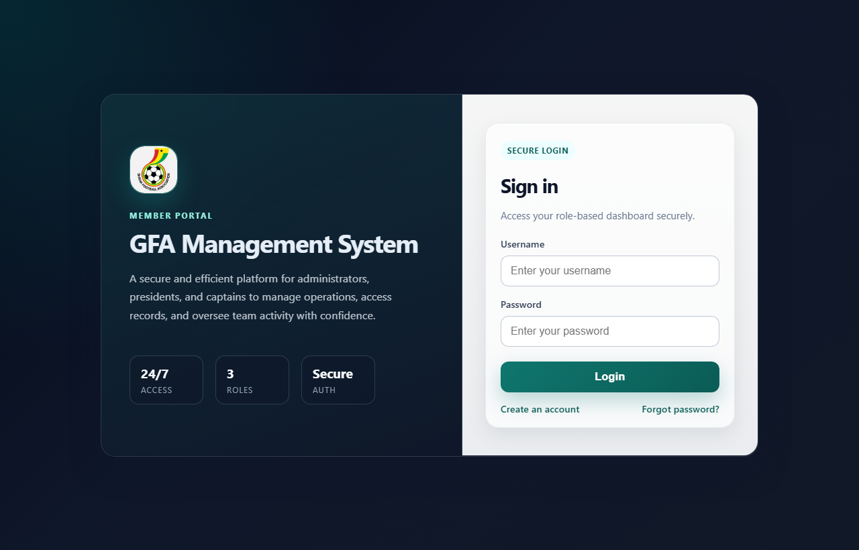
Figure 1: GFA Portal Responsive Login Interface
Figure 1 showcases the entry portal. User credentials submitted here are subjected to salt, pepper, and Argon2id verification with 1-click demo credential fillers.
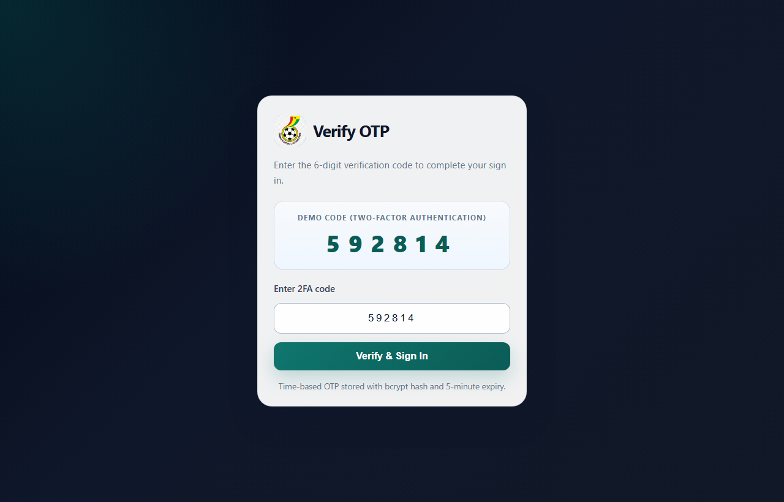
Figure 2: Two-Factor Authentication (2FA) OTP Verification Screen
Figure 2 illustrates the secondary gate prompting for the 6-digit one-time code with strict 5-minute time-to-live enforcement.
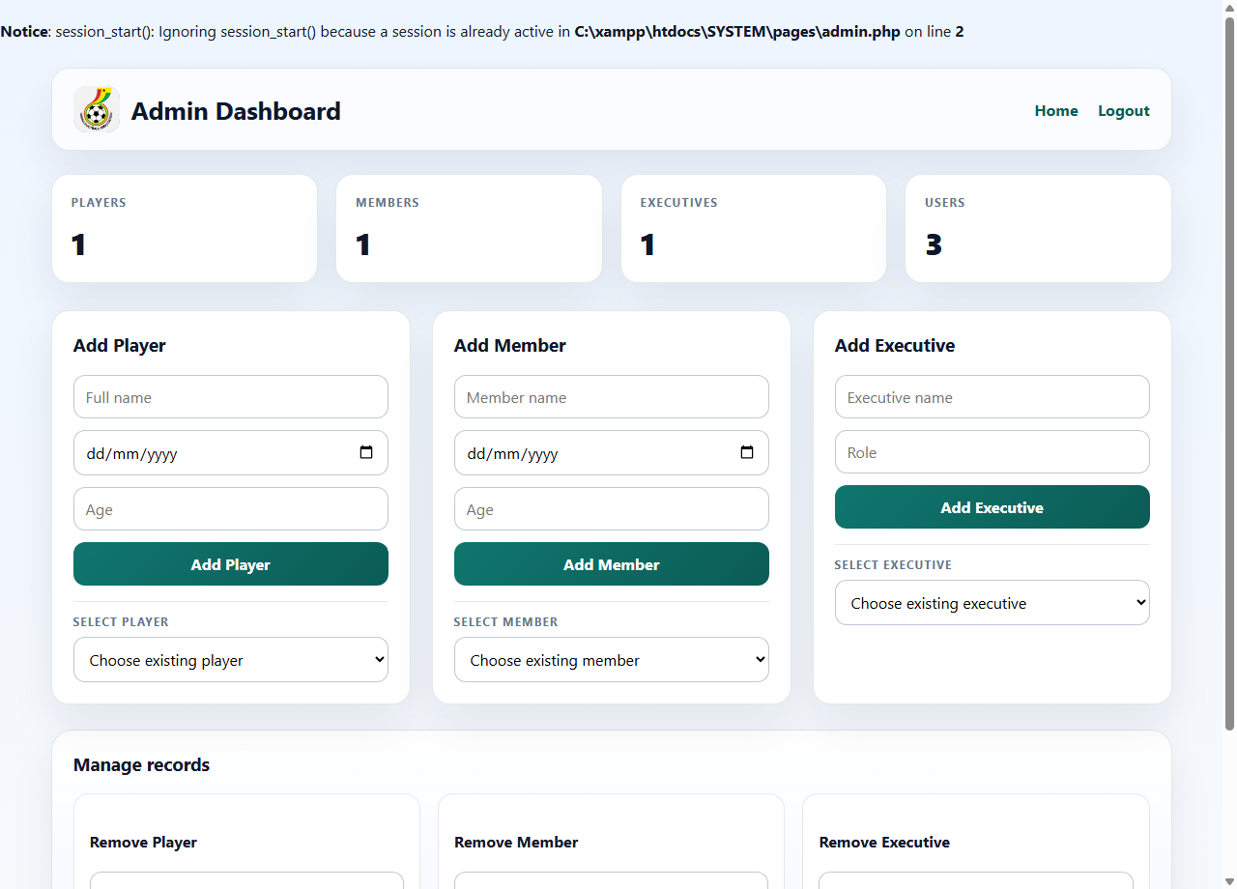
Figure 3: Administrator Operational Dashboard
Figure 3 displays the administrator command center showing real-time statistics, player management, committee administration, and CRUD controls.
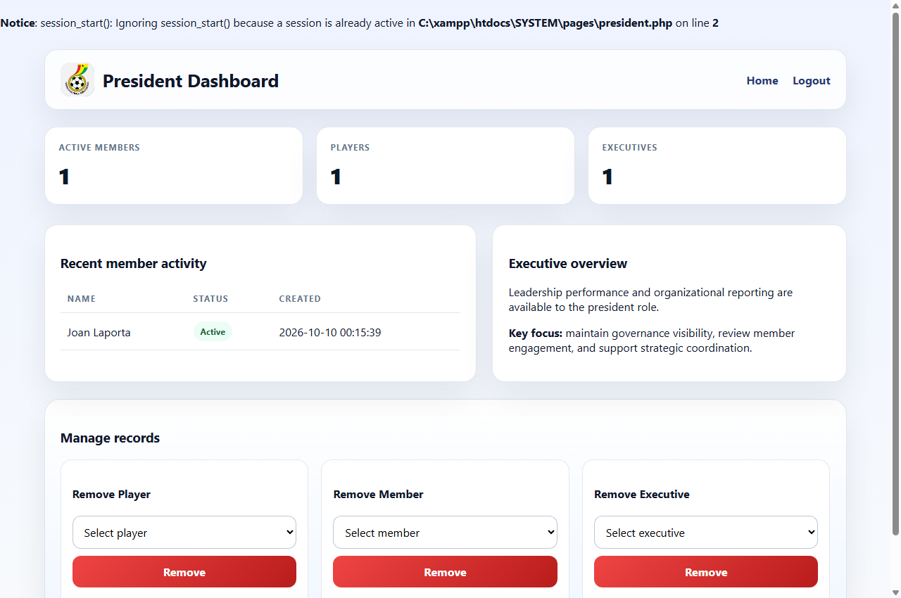
Figure 4: Executive President Dashboard
Figure 4 demonstrates the executive leadership dashboard providing high-level membership tracking and governance controls.
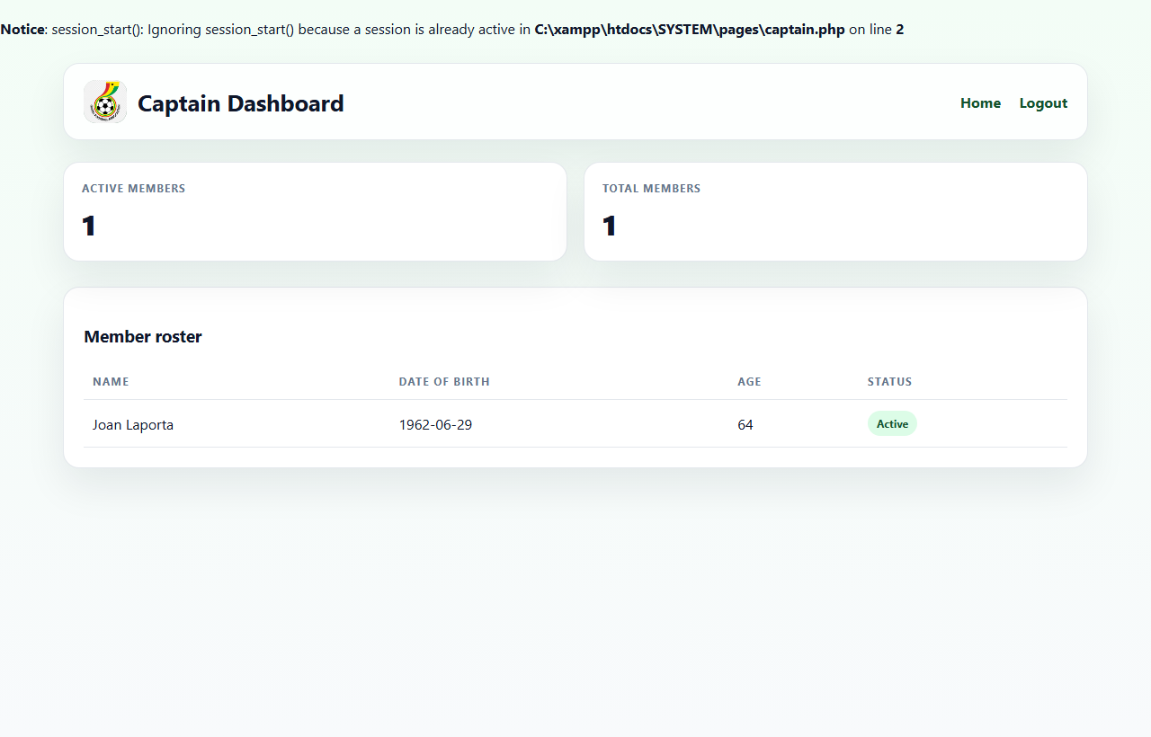
Figure 5: Team Captain Squad Management Dashboard
Figure 5 displays the captain interface restricted strictly to active squad member rosters, ages, and match statuses with read-only permissions.
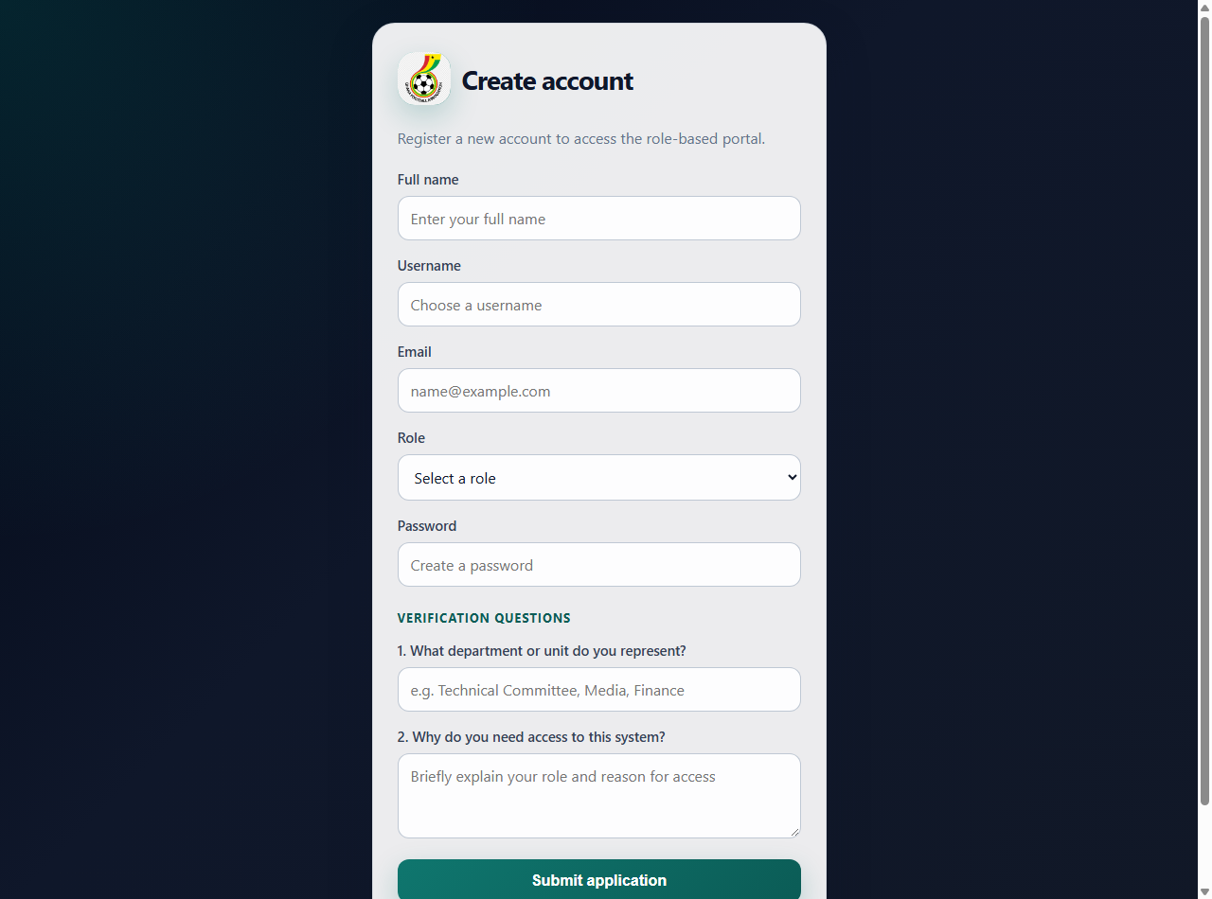
Figure 6: User Account Registration & Vetting Portal
Figure 6 illustrates the new account registration interface supporting dynamic salt generation, Argon2id password hashing, and departmental vetting.
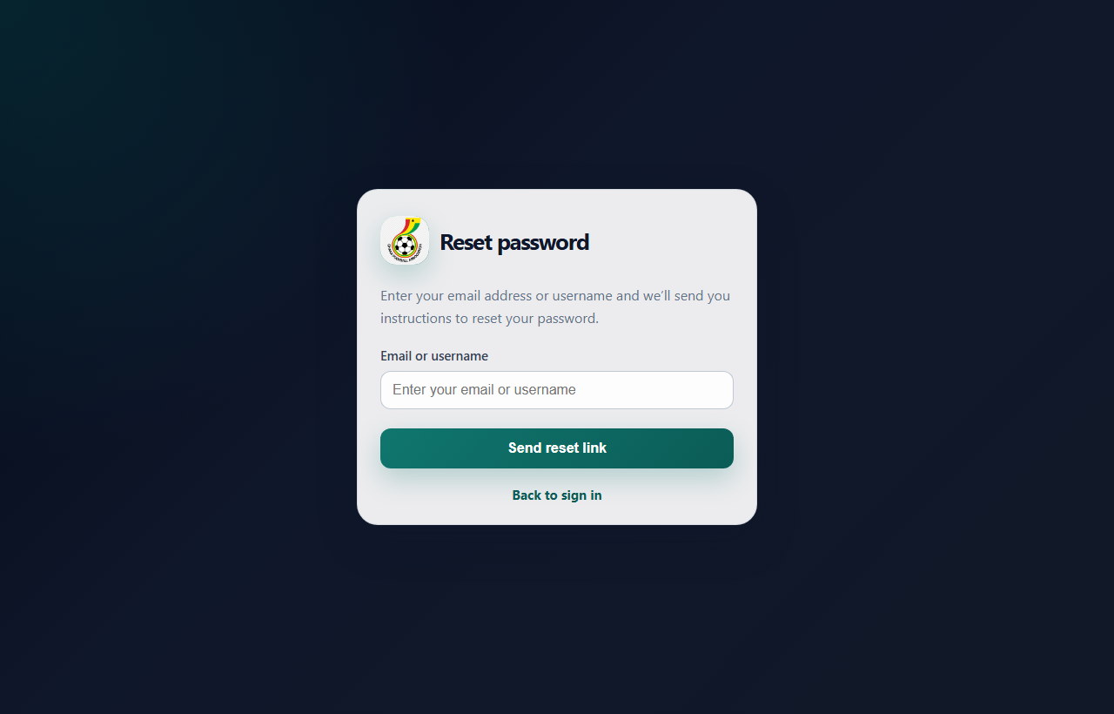
Figure 7: Password Recovery & Identity Verification Interface
Figure 7 depicts the self-service password recovery portal allowing users to securely request credential reset workflows.
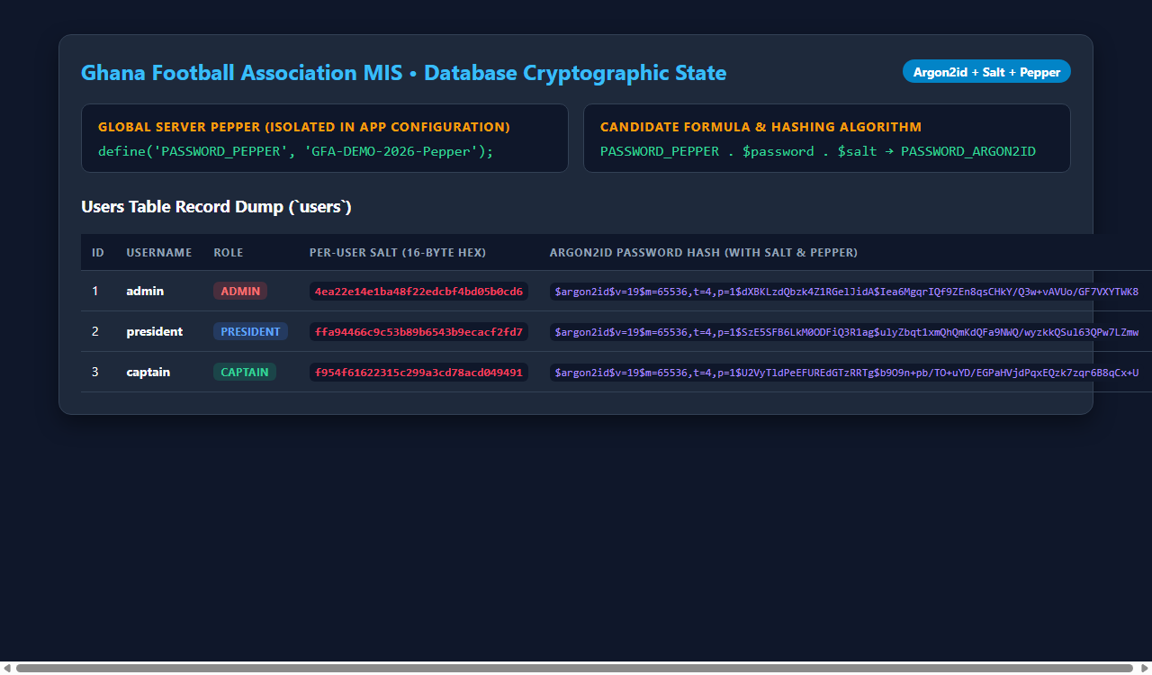
Figure 8: Live MySQL Database Cryptographic State
Figure 8 provides forensic database evidence illustrating individual 16-byte hex salts, Argon2id password hashes, and isolated server pepper configuration.
6. Role-Based Access Control (RBAC) Matrix
Privilege separation is enforced strictly by session guards on every page request. The access matrix below defines role capabilities:
System Capability / Action | Administrator | President | Captain
View Portal Home & Login | Allowed | Allowed | Allowed
Authenticate via Salt + Pepper + 2FA | Allowed | Allowed | Allowed
Access Admin Dashboard (/pages/admin.php) | Allowed | Denied (302 Redirect) | Denied (302 Redirect)
Access President Dashboard (/pages/president.php) | Denied (302 Redirect) | Allowed | Denied (302 Redirect)
Access Captain Dashboard (/pages/captain.php) | Denied (302 Redirect) | Denied (302 Redirect) | Allowed
Register New Players / Members / Executives | Allowed | Denied | Denied
Delete Players / Members / Executives | Allowed | Allowed (Members/Execs) | Denied
View Squad Roster & Player Age Statistics | Allowed | Allowed | Allowed
Trigger Automated Disaster Recovery Backup | Allowed | Denied | Denied

7. Security Verification Test Log
The following empirical test suite was conducted across the local XAMPP environment and the Vercel production cloud deployment:
Test ID | Security Control | Execution & Test Scenario | Status
TC-01 | Salt & Pepper Hashing | Register/seed users; verify unique 16-byte hex salt in users table and Argon2id hash combines salt + pepper. | PASSED
TC-02 | Credential Validation | Login with valid demo credentials (admin / AdminPass123!); verifyStoredPassword() succeeds. | PASSED
TC-03 | Pepper Rotation Fallback | Execute authentication against secondary fallback pepper in PASSWORD_PEPPER_FALLBACKS array. | PASSED
TC-04 | 2FA Expiry Enforcement | Submit 2FA OTP code after > 5 minutes TTL window; verify system rejects with '2FA code expired'. | PASSED
TC-05 | 2FA Single-Use Security | Attempt to replay a previously verified OTP token; system rejects token reuse. | PASSED
TC-06 | RBAC Horizontal Privilege Escalation | Sign in as Captain and attempt direct GET request to /pages/admin.php; system terminates access and redirects. | PASSED
TC-07 | SQL Injection Neutralization | Inject payload ' OR '1'='1 in login username field; PDO prepared statement neutralizes payload as literal string. | PASSED
TC-08 | Disaster Recovery Backup | Execute php scripts/backup.php; verify mysqldump generates timestamped SQL file and inserts audit log. | PASSED

8. Conclusion
The Ghana Football Association (GFA) Management Information System provides a comprehensive, mathematically grounded demonstration of modern secure software engineering. By weaving the CIA Triad into every architectural tier—combining per-user salts, server pepper secrets, the memory-hard Argon2id algorithm, two-factor authentication, rigid role-based access control, and automated disaster recovery backups—the system offers robust protection against credential cracking, privilege escalation, data corruption, and unauthorized data exfiltration.

